**Lesson 8 Cíntia Domingos**

**Test cases and bugs:**

<https://beetrootqa2024.testrail.io/index.php?/suites/view/65> - Homework has [HW]

<https://beetroot2024.atlassian.net/browse/SCRUM-46> - critical

<https://beetroot2024.atlassian.net/browse/SCRUM-54> - minor

**Beet Sprout**

**2.** Option b. We only have one IF statement, so any test will either be TRUE or FALSE.

**3.** Option b. We need 1 test case to cover the functionality.

**4.** Option b.To check every line of code in the example, we need 1 test case where P > 50 and P + Q > 100.

To test every combination, we need 4 Test cases

P + Q > 100 -> P > 50

P + Q > 100 -> P < 50

P + Q < 100 -> P > 50

P + Q < 100 -> P < 50

**Mighty Beet**

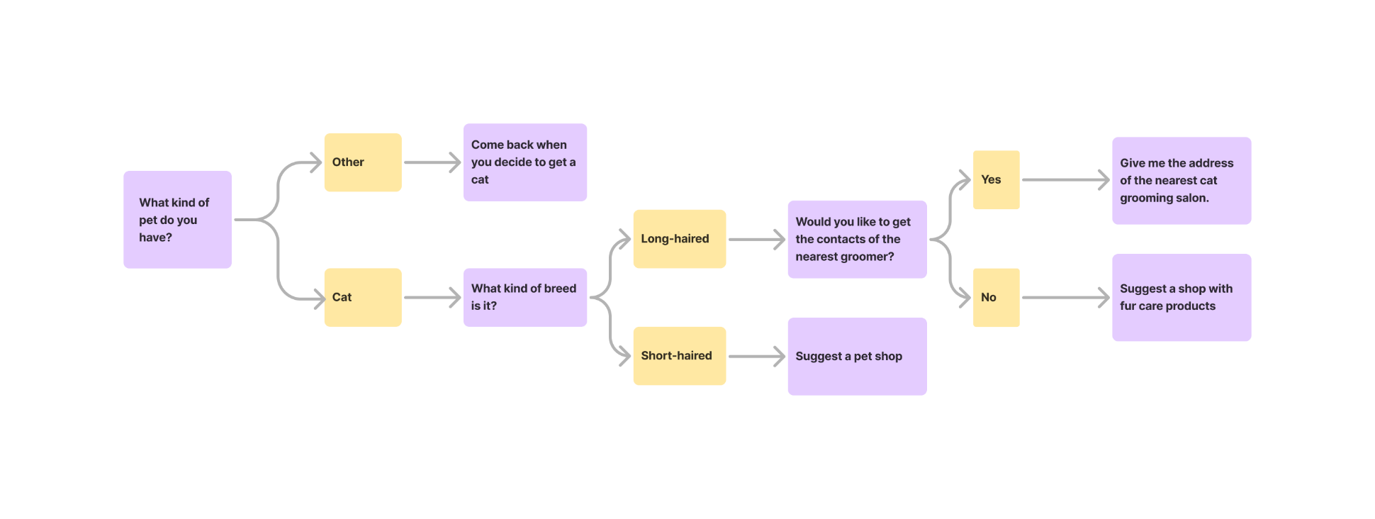**2.1.**

**2.2.**

We need 4 test cases to test all combinations.

Other -> Come back

Cat -> Long -> Yes

Cat -> Long -> No

Cat -> Short